

DMS Renovation
Software Requirement Specification

Project Code: DMS1
Document Code: DMS1_SRS_DefectManagement_v1.0

Ho Chi Minh, May 2014

Record of change

*A - Added M - Modified D - Deleted
Effective Date | Changed Items | A*  M, D | Change Description | New Version
01-May-14 | First release | A |  | 1.0

SIGNATURE PAGE

ORIGINATOR: Vo Quoc Bao 01-May-14

REVIEWERS:

APPROVAL:

Table of content
Table of content 4
1. Defect management 5
1.1. Add Defect 5
1.2. Attachment screen 12
1.3. Defect List screen 17
1.4. Defect View Or Edit screen 24
1.5. Batch Update Defect screen 31
1.6. Export Defect 34
1.7. Defect lifecycle 37
2. Others requirement 39
2.1. Header of page 39
2.2. Data Format 41
2.3. Order of reference data 41
2.4. Timeout requirement 47

Defect management
Defect management is the heart of DMS. It contains following functionalities:
- Add Defect
- Attachment
- Defect List
- Defect View Or Edit
- Batch Update Defect
- Export Defect

  - Add Defect
    - Overview
This screen is used to add new defect to DMS
    - Actors
All project members can add defect to DMS
    - Use-case diagrams
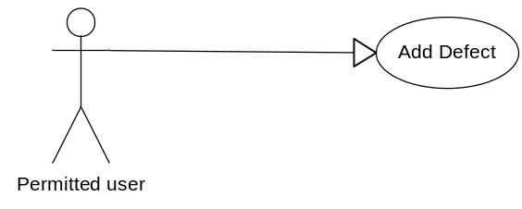
      - Pre-condition
User must be logged in
      - Post-condition
New defect was added into database.
      - Triggers
- Clicks on the “Add New” button on the Defect View or Edit screen
- Go to menu Manage Defect from page header of any page, click on the hyper-link “New Defect”
    - Workflows
Scenario | Actor | System
1. User successfully add new defect | 1.1. Go to this screen | 1.2. Display “Add defect” screen.
1. User successfully add new defect | 1.3 At any time, user can attach file by clicking “Attach file” button  Attachment is optional | 1.4 Submit to “Attach file” screen.  After user attached file, return to “Add new defect” screen with current status and values of all fields and control except change in attachment area.
1. User successfully add new defect | 1.5 Fill in mandatory fields and optional fields (not required) and click “Save” button | 1.6 Validate mandatory fields and valid format.  All fields are valid, new defect will be saved into database and continue to display “Add defect” screen for the next new defect
2. User inputs invalid data | 2.1 Refer to step 1.1 | 2.2 Refer to step 1.2
2. User inputs invalid data | 2.3 Refer to step 1.3 | 2.4 Validate mandatory fields and valid format  If there are still errors, dialog error messages of invalid fields will be displayed at the center of screen
    - External interfaces
      - Prototype:
Add Defect
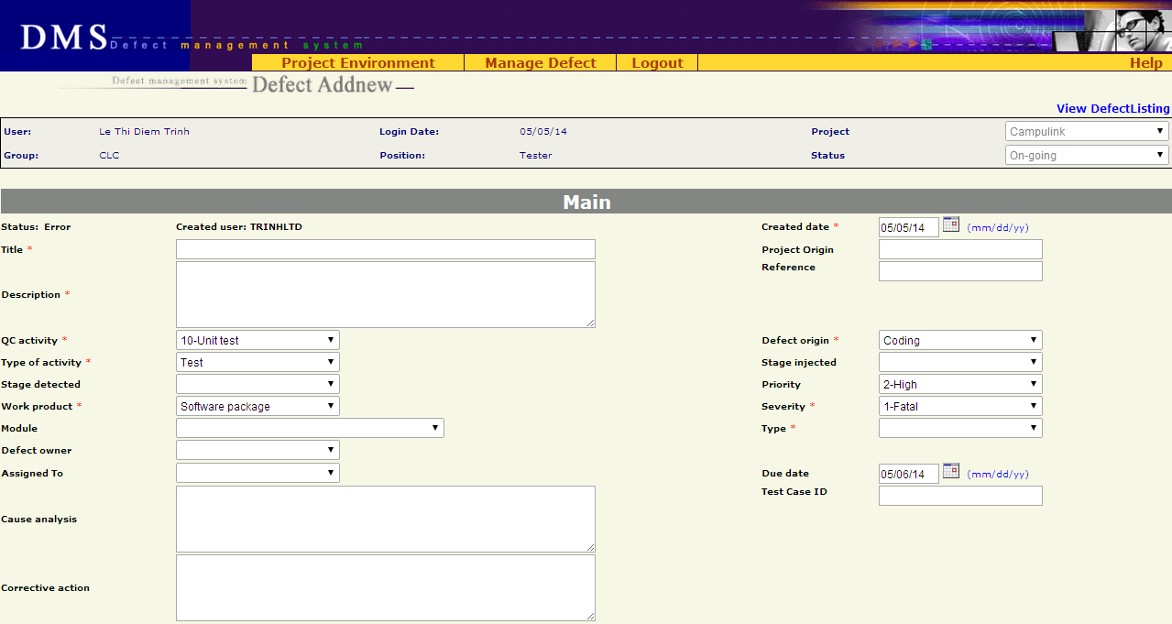
Button
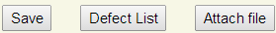
Attachment
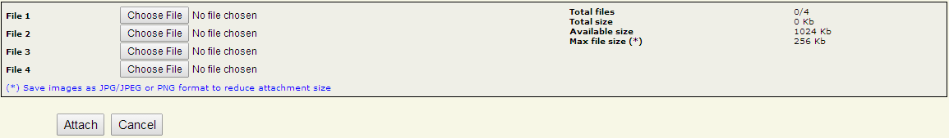
      - Screen description
No | Field name | Control type | Required | Data type | Default value | Description
Defect detail
1 | Status | Label | Yes | Text | Error | Status of the defect.
2 | Created user | Label | Yes | Text | Logged-in user | Member who created the defect and all other members of project
3 | Created Date | Text field | Yes | Date | Today | Date when the defect was recorded in DMS  Date format mm/dd/yy
4 | Title | Text field | Yes | Text | Blank | A short & brief description of the defect for quick recognition  Maximal 150 characters
5 | Project Origin | Text field | No | Text | Blank | Maximal 50 characters
6 | Description | Text area | Yes | Text | Blank | Full description of the defect, often the steps to reproduce the defect
7 | Reference | Text field | No | Text | Blank | Maximal 30 characters
8 | QC Activity | Combo box | Yes | Text | 10-Unit test | QC activity in which the defect is found
9 | Defect Origin | Combo box | Yes | Text | Coding | Process of defect
10 | Type of activity | Combo box | Yes | Text | Test | Defect type of current project
11 | Stage Injected | Combo box | No | Text | Blank | Stage injected of current project
12 | Stage Detected | Combo box | No | Text | Blank | Stage detected of current project
13 | Priority | Combo box | No | Text | 2-High | Indicate how urgent the defect needs to be fixed
14 | Work Product | Combo box | Yes | Text | Software package | Work product in which the defect is found. It is high level CI
15 | Severity | Combo box | Yes | Text | 1-Fatal | Severity of defects in current project
16 | Module | Combo box | No | Text | Blank | Module of defect in current project
17 | Type | Combo box | Yes | Text | Blank | Type of defect
18 | Defect Owner | Combo box | No | Text | Blank | List all members of the project.
19 | Assigned To | Combo box | No | Text | Blank | List all members of the project.
20 | Due Date | Text field | No | Date | Today+1 | Deadline of defect fixing.  Date format mm/dd/yy
21 | Cause Analysis | Text area | No | Text | Blank | Description of the cause of defect
22 | Test Case ID | Text field | No | Text | Blank | ID of test case in which the defect was found  Maximal 50 characters
23 | Corrective Action | Text area | No | Text | Blank | Actions/steps to correct the defect
Button
24 | Save | Button | Yes | N/A | N/A | Save new defect to database and go to “Add Defect” screen
25 | Defect List | Button | Yes | N/A | N/A | Return to “Defect List” screen corresponding to previous selected query (All defects / All Open Defects / All Leakage Defects / Public or Private Query)
26 | Attach file | Button | Yes | N/A | N/A | Go to “Attach file” screen
    - Business descriptions
No | Name | Control Type | Description
Defect detail
1 | QC Activity | Combo box | When “QC Activity” changes, appropriate values of “Type of Activity” will be automatically generated
2 | Type of Activity | Combo box | This information won’t be inputted by user.  System will add Type of Activity information according to QC Activity
3 | Stage Detected - Injected | Combo box | Information of 2 stages will come from FI accordant to “today”
4 | Priority | Combo box | Priority of defect
5 | Work Product | Combo box | Work product in project
6 | Severity | Combo box | Severity of defect
7 | Module | Combo box | Available values are automatically got from another Project management tool  From this available values, list all appropriate “Modules” of “Work Product”
8 | Type | Combo box | List all defect types of system
9 | Created user | Combo box | User can choose any member of project
10 | Assigned to | Combo box | User can choose any member of project
11 | Defect Owner | Combo box | User can choose any member of project
12 | Defect ID | Text | This number is automatically generated whenever a new defect is added. Defect ID counter will not be reset.
13 | Re-opened | N/A | This property is not displayed in screen. It will be automatically set to 0 each time a new defect is created.
14 | Translation status | Hidden | Available values are: Not translated, Translated, Reviewed  This field is automatically set to “Not translated” whenever a new defect is created
15 | Due Date | Text | Default value is today + 1
16 | Defect Title | Text | Focus on Defect Title item at the first load
Button
17 | Defect list | Button | Return to “List Defect” screen of previous chosen query (All Defects, All Open Defects, …)
18 | Attach file | Button | Go to attachment screen
    - User-validation rules
No | Validation rule | Message Code
1 | Combo box is required | ERR_REQUIRED_QC_ACTIVITY  ERR_REQUIRED_ORIGIN  ERR_REQUIRED_TYPE_ACTIVITY  ERR_REQUIRED_WP  ERR_REQUIRED_SEVERITY  ERR_REQUIRED_TYPE
2 | Date format mm/dd/yy | ERR_FORMAT_DATE_CREATED  ERR_FORMAT_DATE_DUE
3 | Text field/text area is required | ERR_REQUIRED_CREATED_DATE  ERR_REQUIRED_TITLE  ERR_REQUIRED_DESCRIPTION
4 | Created date is greater than current date | ERR_CONSTRAINT_DATE_CREATED_TODAY
5 | Created date is greater than Due Date | ERR_CONSTRAINT_DATE_CREATED_DUE
6 | Length of input fields are over limitation | No message, auto trim string
    - Related use-cases
- List defect
- Attach file

  - Attachment screen
    - Overview
This function is described for the updating/attaching some files to a defect while user creates a new defect or updates an existing defect. In this screen, user will have information on attachments of the defect, including: total number of attached file(s), total size of attached file(s) and available size for next attachment.
    - Actors
All users who have permission to attach files to a defect.
    - Use – case diagram
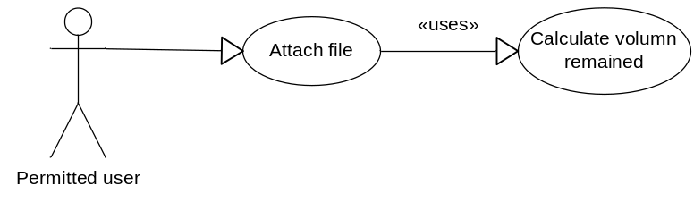
      - Pre-condition
- The actor has successfully logged into the system.
- There’s enough available space for attachment
      - Post-condition
N/A
      - Triggers
From Add Defect, Defect View Or Edit screen, user clicks on the Attach file button to view Attach files screen.
    - Workflows
      - Scenario 1 – Valid Attachment
Actor | System
1. From Add Defect, Defect View Or Edit screen, user clicks on the Attach File button | 2. Display Attach files screen
3. User choose some files by clicking on the Choose file button to open Choose File dialog
4. After choosing file, User clicks on Attach button | 5. Validate all inputs  - If all inputs are valid  ➔ Upload files to server and display Upload Attachment Result screen with successful message
6. On Upload Attachment result screen, user clicks on Done button. | 7. Return to the Add Defect, Defect View Or Edit screen
      - Scenario 2 – Invalid Attachment
Actor | System
Step 1, 2, 3 – refer to scenario 1
Step 4 – refer to scenario 1 | 5. Validate all inputs  - If any input is invalid  ➔ Go to Upload Attachment Result screen with fail message
6. On Upload Attachment result screen, user clicks on Done button. | 7. Return to the Add Defect, Defect View Or Edit screen

    - External interfaces
      - Prototype
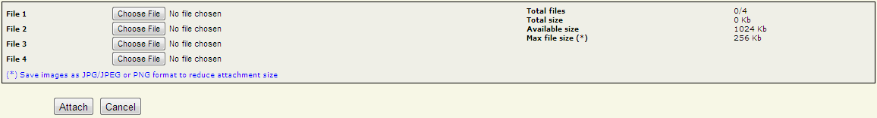
Figure: Attach file screen

Figure: Upload attachment result screen

      - Screen Description
This function uses two screens: Upload Attachment screen, Upload Attachment result screen
        - Attach file screen
No | Field name | Control type | Data type | Default Value | Require | Functional Description/(*) Tool tip
1 | File X | Label Area | Text | Blank | Yes | There are always 4 file browsing item in this screen
2 | Total files, Total size, Available Size, Max file size (*) | Label Area | Text | N/A | Yes | Information includes:  - Total uploaded files,  - Total size of attached files  - Available size for next attachment  - Maximum uploaded file size
3 | Attach | Button | Control | N/A | Yes | Upload the chosen file(s) to server.
4 | Cancel | Button | Control | N/A | Yes | Reset and close the dialog to return to Add Defect, Defect View Or Edit screen

        - Upload Attachment result screen
No | Field name | Control type | Data type | Functional Description/(*) Tool tip
1 | File(s) attached successfully | Label Area | Text | Incase success when attaching file  - New files = number of attached file  - New size = Total size of attached files  - Total files = <number attached file>/4  - Total size = Total size (old & new) Kb  - Available size = <1024 – Total size> Kb
1 | Attach failed due to error | Label Area | Text | Incase fail when attaching file  - New files = 0  - New size = 0 Kb  - Total files = 0/4  - Total size = 0 Kb  - Available size = 1024 Kb
2 | Done | Button | Control | Return to Add Defect, Defect View Or Edit screen with the new attachment list

    - Business Description
      - Upload Attachment screen
No | Name | Business rules
1 | Upload/ Attachment screen  General constraints | - Limitation for file size = 256 Kb  - Limitation for number of file = 4  - Total size of all attachments doesn’t exceed 1024 Kb  - To reduce size of attachment, save images as JPG, JPEG or PNG format  - In addition, attachment can be any format such as .doc, .xls, .txt, .zip, .rar…

No | Name | Business rules
1 | From Add Defect, Defect View Or Edit screen, user clicks on Attach File button. | Display Upload Attachment screen ➔  open Choose file dialog to browse the required file to attach
2 | In Upload Attachment screen:  User clicks on Cancel button | Reset and close the dialog to return to Add Defect, Defect View Or Edit screen
3 | - User clicks on Attach button - If all the file paths are valid, the file size is not bigger than the limitation of attachment for a defect and the available space is enough  ➔ The chosen file(s) uploaded to server. If upload run successfully  ➔ Display Upload Attachment screen – result
4 | File name | File name of the attachment must be different to old attachments’ name

      - Upload Attachment result screen
- Control area

No | Name | Business rules
1 | User clicks on Done button | Return to Add Defect, Defect View Or Edit screen with the new attachment list

    - User validation rules
No | Error type | Message Code
1 | user did not select any file for attachment when clicking Attach button | ERR_REQUIRED_ATTACHMENT_FILE
2 | Total size is over the limitation (1024 Kb) | ERR_FILE_OVER_AVAILABLE_SIZE
3 | file size is over the limitation (256 Kb) | ERR_FILE_OVER_MAX_FILE_SIZE
4 | File name is same to old attachment’s name in the project | ERR_EXISTED_FILE_NAME
    - Related use-cases
- Defect View Or Edit
- Add new Defect

  - Defect List screen
    - Overview
This screen displays a list of defects matching a previously chosen query and specific search criteria if filter was applied.
    - Actors
All users can view defect list
    - Use-case diagram
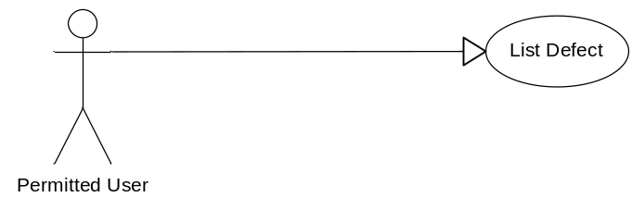
      - Pre-condition
User must be logged-in.
      - Post-condition
List of suitable defects was displayed.
      - Triggers
- User selects a query of listing in homepage
- User clicks Defect List button in Add Defect and Update Defect screens
    - Workflows
      - Scenario 1 (Fixed Query - Filter)
Actor | System
1. User click on a fixed query (All Defects, All Open Defects, All Leakage Defects) | 2. The corresponding list defect is displayed with the set of criteria as follows:  - Defect Owner  - Status  - Module Code  - Assigned To  - Severity  - Type  - Created By  - Reference  - Defect Origin  - Stage Detected  - Stage Injected  - QC Activity  - Created From  - Created To  - Work Product  - Fixed From  - Fixed To  - Priority  - DefectID  - Test Case ID  - Title
3. User enters information related to searching defects in the Filter section.
4. User click on the button “Search” | 5. The corresponding list defect is displayed on a table
    - GUI
      - Prototype
Filter:
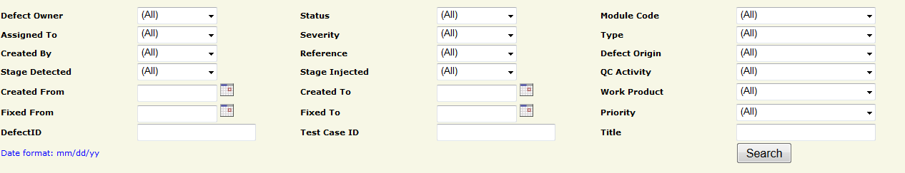
List defects:
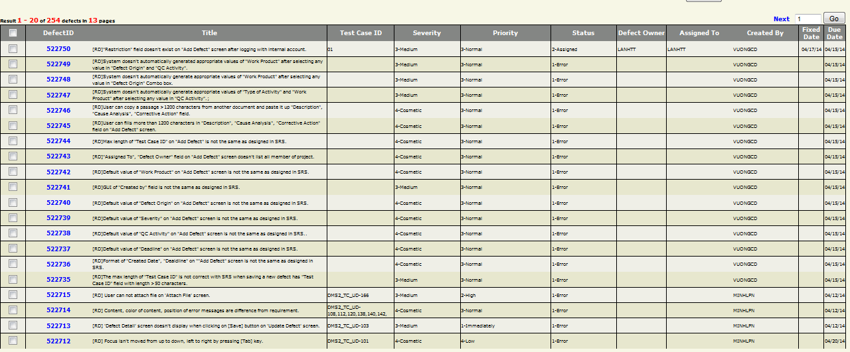
Control area:
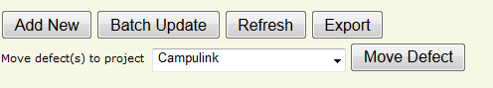
      - Screen Description
        - Zone 1 - filter
No | Field  Name | Control Type | Data Type | Default Value | Required | Functional  Description/(*)ToolTip
1 | Defect Owner | Combo box | Text | All | No | Owner of defects searching. List all members of the project. Besides, it has 2 more items: (All) and None
2 | Status | Combo box | Text | All | No | Status of defect. Depend on project model. Besides, it has 1 more item: (All)
3 | Module Code | Combo box | Text | All | No | Module which contain defects user wants to search. Besides, it has 2 more items: (All) and (None)
4 | Assigned To | Combo box | Text | All | No | List of all members of the project. Besides, it has 2 more items: (All) and (None)
5 | Severity | Combo box | Text | All | No | Severity of defects in current project, similar to current DMS values. Besides, it has 1 more item: (All)
6 | Type | Combo box | Text | All | No | Defect type of the defects searching, similar to current DMS values.  Besides, it has 1 more item: (All)
7 | Created By | Combo box | Text | All | No | Member who creates the defect is selected in the list of all members of the project... Besides, it has 2 more items: (All)
8 | Reference | Combo box | Text | All | No
9 | Defect Origin | Combo box | Text | All | No | Indicates the actual process that caused the defect, similar to current DMS values.  Besides, it has 1 more item: (All)
10 | Stage Detected | Combo box | Text | All | No | Stage of project when defect is detected
11 | Stage Injected | Combo box | Text | All | No | Stage of project when defect is resolved
12 | QC Activity | Combo box | Text | All | No | QC Activity of defects searching, similar to current DMS values.  Besides, it has 1 more item: (All)
13 | Created From | Text field | Date | Blank | No | Minimal creation date of the defects searching  Current date format of project
14 | Created To | Text field | Date | Blank | No | Maximal creation date of the defects searching  Current date format of project
15 | Work Product | Combo box | Text | All | No | Work Product in which found the defects, similar to current DMS values.  Besides, it has 1 more item: (All)
16 | Fixed From | Text field | Date | Blank | No | Minimal fixed date of the defects searching  Current date format of project
17 | Fixed To | Text field | Date | Blank | No | Maximal fixed date of the defects searching  Current date format of project
18 | Priority | Combo box | Text | All | No | List priority that the defect need to be resolved. Besides, it has 2 more items: (All) and None
19 | Defect ID | Text field | Text | Blank | No | The beginning value that the defects searching contains
20 | Test Case ID | Text field | Text | Blank | No | The Test Case ID which found the defects
21 | Title | Text field | Text | Blank | No | The title that defects searching contains
22 | Search | Button | Control |  | No | Button allows user to search defects by selected criteria
23 | Date format | Text | Text | mm/dd/yy | Yes | Date format of displayed date value
        - Zone 2 - Paging area
No | Field name | Control Type | Data Type | Default Value | Required | Functional  Description/(*)ToolTip
1 | Go | Button |  |  |  | Go to selected page in paging mode
2 | Selected page | Text field | Text | 1 | Yes | Selected page value in paging mode
3 | Prev | Link | Image |  |  | Go to previous page in paging
4 | Next | Link | Image |  |  | Go to next page in paging
        - Zone 3 – Defects listing area
No | Field  Name | Control Type | Data  Type | Default Value | Required | Functional Description/ (*)ToolTip
1 | Check | Check box | Boolean | False | No | Selected defects will be used for batch update functionality
2 | Defect ID | Link | Text |  | No | Link to “Defect View Or Edit” page
3 | Title | Text | Text |  | No | Short description of content of defect
4 | Test Case ID | Text | Text |  | No | ID of test case that found the defect
5 | Severity | Text | Text |  | No | Severity of defect
6 | Priority | Text | Text |  | No | Priority of defect
7 | Status | Text | Text |  | No | Status of defect
8 | Defect owner | Text | Text |  | No | Owner of defect
9 | Assigned To | Text | Text |  | No | Who is assigned to fix defect
10 | Created By | Text | Text |  | No | Who created defect
11 | Fixed Date | Text | Date |  | No | Date when defect was fixed  Current date format of project
12 | Due Date | Text | Date |  | No | Deadline for defect fixing  Current date format of project
        - Zone 4 – Control area
No | Field Name | Control Type | Data  Type | Default Value | Required | Functional  Description/(*)ToolTip
1 | Add New | Button | Text | N/A | N/A | Link to create new defect page
2 | Batch Update | Button | Text | N/A | N/A | Submit selected defects to batch update page
3 | Refresh | Button | Text | N/A | N/A | Refresh the page
4 | Export | Button | Text | N/A | N/A | Permit user to export defects to excel file
5 | Move defect(s) to project | Combo box | Text | N/A | N/A | Destination projects for moving defects
6 | Move Defect | Button | Text | N/A | N/A | Permit QA to move defects to selected project (visible with QA only)
    - Business description
      - Zone 1 - Filter
No | Field Name | Business Rules
1 | Assigned To, Created By, Defect Owner | - Combo box contains all users assigned to the project
2 | Status | - Combo box contains a list of defect status
3 | Severity | - Combo box contains a list of defect severity values
4 | Module Code | - Combo box “Module Code” contains a list of module code values  - At the first load, Module code combo box contains all modules
5 | QC Activity | - Combo box contains a list of QC Activity values
7 | Priority | - Combo box Priority contains a list of Priority values
9 | Type | - Combo box contains a list of defect type values
10 | Defect Origin | - Combo box contains a list of Origin values
12 | Work Product | - Combo box contains a list of Work Product values
13 | DefectID | - Search all defects that begin with inputted value
14 | Defect Owner | - Combo box contains all members of the selected project
16 | Title | Search all defects which have relative value with inputted value
17 | Test Case ID | Search relative value
      - Zone 2 – Defects listing area
No | Field Name | Business Rules
1 | Check | - Used for “Batch Update”  - If user clicks the check icon on the header row, all check boxes will be checked
2 | DefectID | - Link to “Defect View Or Edit” page  - Refer to use-case “Defect View Or Edit”  - If user clicks the icon “DefectID” on the header row , all values of the result table will be sorted by this field
3 | Title | - If user clicks the icon “Title” on the header row , all values of the result table will be sorted by this field
4 | Test Case ID | - If user clicks the icon “Test Case ID” on the header row , all values of the result table will be sorted by this field
5 | Severity | - If user clicks the icon of this field on the header row , all values of the result table will be sorted by this field
6 | Priority
7 | Status
8 | Defect Owner
9 | Assigned To
10 | Created By
11 | Fixed Date
12 | Due Date
    - User – validation rules
No | Validation rule | Message Code
1 | Date format mm/dd/yy | ERR_FORMAT_DATE_CREATED_FROM  ERR_FORMAT_DATE_CREATED_TO  ERR_FORMAT_DATE_FIXED_FROM  ERR_FORMAT_DATE_FIXED_TO
2 | Created From Date > Created To Date | ERR_CONSTRAINT_DATE_CREATED_FROMTO
3 | Fixed From Date > Fixed To Date | ERR_CONSTRAINT_DATE_FIXED_FROMTO
4 | Input data that is characters/specific characters/negative number is filled in “DefectID” | ERR_DEFECT_ID_INVALID
5 | Selected page is out of range or not a positive number | ALT_PAGE_INVALID
6 | No defect is checked to batch update | ALT_REQUIRED_DEFECT
    - Related use-cases
- Add defect
- Defect View Or Edit
- Batch update
- Export defect

  - Defect View Or Edit screen
    - Overview
With this function, user can update existed defect and save the modification. All members of project can update the defect.
    - Actors
All project members can update defect.
    - Use-case diagram
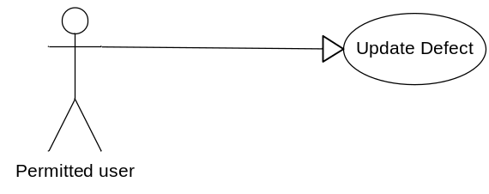
      - Pre-condition
User must be logged-in the system.
      - Post-condition
N/A
      - Triggers
    - User clicks on Defect ID in defects list screen
    - Workflows
Actor | System
1. Go to “Defect View Or Edit” screen | 2. Display “Defect View Or Edit” screen with all available data fields related to a specific actor  Display current values of defect for user to update
3. Update value of data fields & click “Save” button | 4. Validate data fields  If all fields are valid, defect will be updated in database and go to the page “Defect List”
    - External interfaces
      - Prototype
Defect View Or Edit
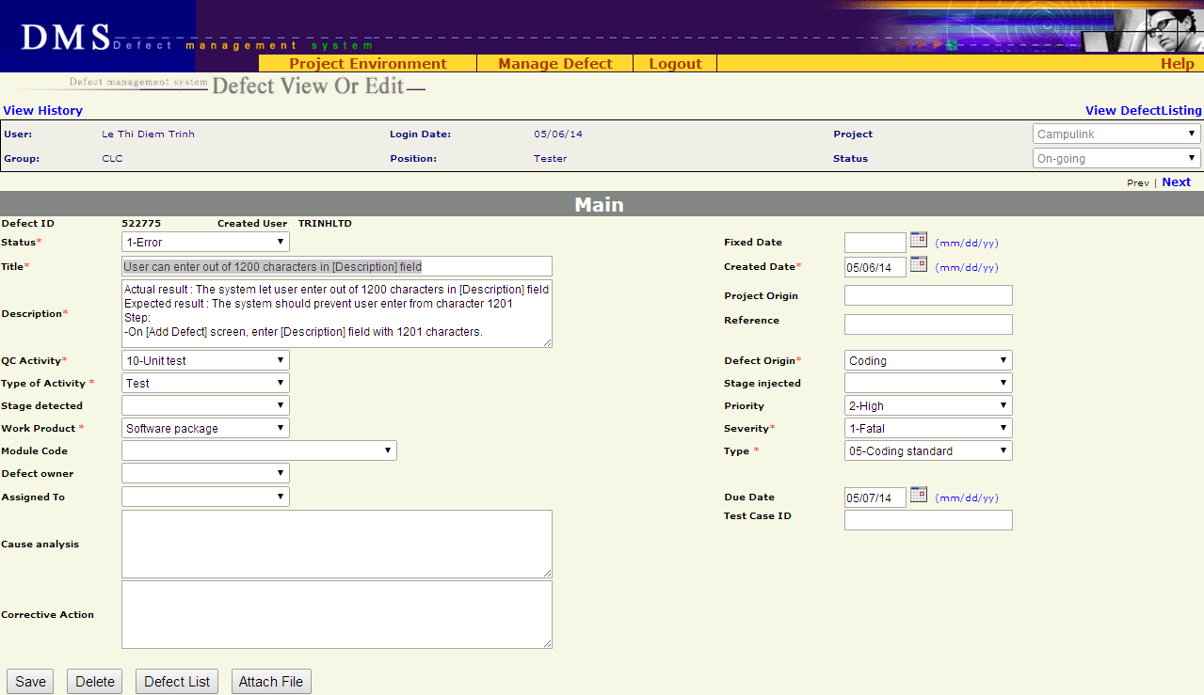
      - Screen descriptions
No | Field name | Control Type | Required | Data type | Default value | Description

Defect detail
1 | Status | Label | Yes | Text | Current Value | Status of the defect.
2 | Fixed Date | Text field | No | Date | Blank | Date when the defect was fixed  Date format mm/dd/yy
3 | Title | Text field | Yes | Text | Current Value | A short & brief description of the defect for quick recognition
4 | Created Date | Text field | Yes | Date | Current Value | Date when the defect was recorded in DMS  Date format mm/dd/yy
5 | Description | Text area | Yes | Text | Current Value | Full description of the defect, often the steps to reproduce the defect
6 | Project Origin | Text field | No | Text | Current Value
7 | Reference | Text field | No | Text | Current Value
8 | QC Activity | Combo box | Yes | Text | Current Value | QC activity in which the defect is found
9 | Defect Origin | Combo box | Yes | Text | Current Value | Process of defect
10 | Type of activity | Combo box | Yes | Text | Current Value | Defect type of current project
11 | Stage Injected | Combo box | No | Text | Current Value | Stage injected of current project
12 | Stage Detected | Combo box | No | Text | Current Value | Stage detected of current project
13 | Priority | Combo box | No | Text | Current Value | Indicate how urgent the defect needs to be fixed
14 | Work Product | Combo box | Yes | Text | Current Value | Work product in which the defect is found. It is high level CI
15 | Severity | Combo box | Yes | Text | Current Value | Severity of defects in current project
16 | Module Code | Combo box | No | Text | Current Value | Module of defect in current project
17 | Type | Combo box | Yes | Text | Current Value | Type of defect
18 | Defect Owner | Combo box | No | Text | Current Value | List all members of the project.
19 | Assigned To | Combo box | No | Text | Current Value | List all members of the project.  If combo box “Assigned To” is chosen, status will be changed to Assigned by system
20 | Due Date | Text field | No | Date | Current Value | Deadline of defect fixing.  Date format mm/dd/yy
21 | Cause Analysis | Text area | No | Text | Current Value | Description of the cause of defect
22 | Test Case ID | Text field | No | Text | Current Value | ID of test case in which the defect was found  Maximal 50 characters
23 | Corrective Action | Text area | No | Text | Current Value | Actions/steps to correct the defect

Button
24 | Save | Button | N/A | N/A | N/A | Save current defect to database and return to “List defect” screen
25 | Delete | Button | N/A | N/A | N/A | Delete current defect
26 | Defect list | Button | N/A | N/A | N/A | Return to “Defect List” screen corresponding to previous selected query (All defects / All Open Defects / All Leakage Defects / Public or Private Query)
27 | Attach file | Button | N/A | N/A | N/A | Submit the defect to “Attach file” screen
    - Business descriptions
No | Name | Description
Defect detail
1 | Assigned To | User can choose any member of project
2 | Module Code | Available values are automatically got from another Project management tool  From this available values, list all appropriated “Modules” of “Work Product”
3 | Type | List all defect types of system
4 | Title | Can be updated by all members of project
5 | Description | Can be updated by all members of project
6 | Defect Owner | List all members of team that are assigned to project
7 | Due Date | Default value is today+1 if there is no value for this field
8 | Title | Focus on Defect Title item at the first load
9 | Corrective Action | If Status is changed to “3-Pending”, “4-Tested”, “5-Accepted” or “6-Cancelled” then “Corrective Action” must be filled.
Button
10 | Save | Validate all fields  If all fields are valid, save the defect in database and go to “Add Defect” screen. Save all information in Update screen including comment (if any)
11 | Delete | Delete the defect from database and go to “Defect List” screen.
12 | Defect List | Move to “Defect List” screen
13 | Attach file | Only Created user, Assignee and full-right users (PM, PTL, QA) can use this functionality  Submit the defect to “Attach file” screen
    - User-Validation rules
No | Validation rule | Error message ID
1 | Combo box is required | ERR_REQUIRED_STATUS  ERR_REQUIRED_QC_ACTIVITY  ERR_REQUIRED_DEFECT_ORIGIN  ERR_REQUIRED_TYPE_ACTIVITY  ERR_REQUIRED_WP  ERR_REQUIRED_SEVERITY  ERR_REQUIRED_TYPE
2 | Date format mm/dd/yy | ERR_FORMAT_DATE_CREATED  ERR_FORMAT_DATE_FIXED  ERR_FORMAT_DATE_DUE
3 | Text field/text area is required | ERR_REQUIRED_TITLE  ERR_REQUIRED_CREATED_DATE  ERR_REQUIRED_DESCRIPTION
4 | Created date is greater than current date | ERR_CONSTRAINT_DATE_CREATED_TODAY
5 | Fixed date is greater than current date | ERR_CONSTRAINT_DATE_FIXED_TODAY
6 | Created date is greater than fixed date | ERR_CONSTRAINT_DATE_CREATED_FIXED
    - Related use-cases
- List defect
- Attach file

  - Batch Update Defect screen
    - Overview
This function permit user to update concurrently some defects of the same batch. User must select defects from List Defect screen before using Batch Update.
    - Actors
All users who have permission on Batch update functionality (defined in RMS)

    - Use - case diagram
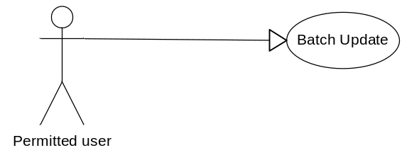
      - Pre-condition
- The actor has successfully logged into the system.
- User has selected at least one defect to update
      - Post-condition
N/A
      - Triggers
From List Defect screen, user selects some necessary defects for updating and clicks on Batch Update button.
    - Workflows
      - Scenario – Batch update
Actor | System
1. From List Defect screen, user selects some necessary defects for updating
2. User clicks on Batch Update button. | 3. Display Batch Update screen
4. User change some necessary fields of the selected defects
5. User clicks on Save button | 6. Save all modifications and return to List Defect screen.
    - External interfaces
      - Prototype
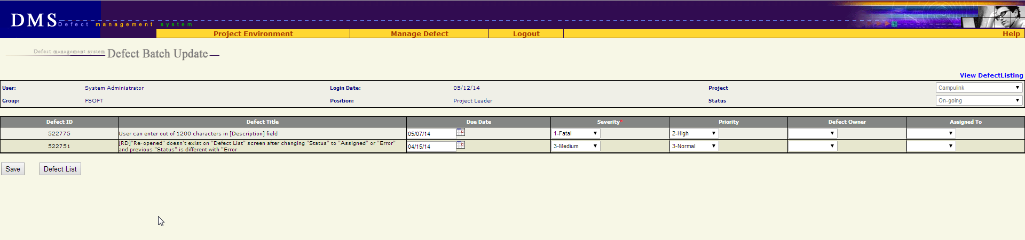
      - Screen Description
Each defect is listed here with following information:
No | Field name | Control type | Data type | Default value | Require | Functional Description/(*) Tool tips
1 | Defect ID | Label | Text | Copy from previous | N/A | ID number of defect  Cannot be edited
2 | Defect Title | Label | Text | Copy from previous | N/A | This is a brief description about defect  Cannot be edited
3 | Due Date | Text box | Text | Copy from previous | No | This is the date on which the defect should be fixed  - Associated with a date picker calendar  - format dd/mm/yy
4 | Severity | Combo box | Text | Copy from previous | Yes | Severity of defect
5 | Priority | Combo box | Text | Copy from previous | No | Priority of defect
6 | Defect Owner | Combo box | Text | Copy from previous | No | This field indicates who is owner of the defect  List all members of the project
7 | Assigned to | Combo box | Text | Copy from previous | No | This field indicates who will be responsible for fixing the defect  List all members of the project
    - Business Description
      - Data fields
No | Name | Business rules
1 | Defect Owner | User can assign owner for defect to any member of project
2 | Assigned To | User can assign defect to any member of project
      - Control area
No | Name | Business rules
1 | From List Defect screen, user clicks on Batch Update button | Go to Batch Update screen with the list of selected defects
2 | At Batch Update screen, user clicks on Defect List button | Return to List Defect screen without saving any thing
3 | User clicks on Save button | Save all changes and return to List Defect screen
    - User validation rules
No | Error type | Message Code
1 | Due date is in invalid format | ERR_FORMAT_DATE_DUE
    - Related use-cases
- Defect List

  - Export Defect
    - Overview
This screen allows user to export defects list retrieved from “Defect List” screen.
    - Actors
All users who has permission on Export functionality
    - Use-case diagram
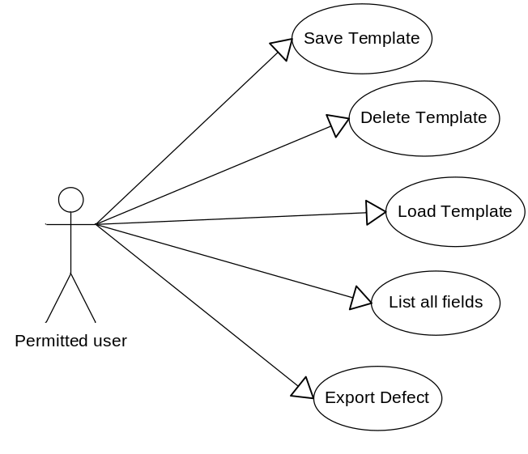
      - Pre-condition
User must be logged-in.
      - Post-condition
Defects were exported to a file.
      - Triggers
In “Defect List” screen, user click “Export” button.
    - Workflow
Actor | System
1/ Click “Export” button from “Defect List” screen | 2/ Defect which are being displayed in “Defect List” is exported  The exported file is saved in download link of browser.  Type of file: excel
    - External interfaces
      - Prototype
Defect is exported to excel file
      - File description
No | Field name | Description
1 | #
2 | DefectID
3 | Title
4 | Test Case ID
5 | Severity
6 | Priority
7 | Status
8 | Defect Owner
9 | Assign To
10 | Created By
11 | Create Date
12 | Fixed Date
13 | Due Date
14 | Description
15 | Project Origin
16 | Reference
17 | QC Activity
18 | Defect Origin
19 | Activity Type
20 | Stage Injected
21 | Stage Detected
22 | Work Product
23 | Module
24 | Defect Type
25 | Corrective Action
26 | Closed Date
27 | Cause Analysis
    - User – validation rules
No | Name | Message Code
1 | Export list is empty | ALT_REQUIRED_EXPORT_LIST
    - Related use-cases
- Defect List

  - Defect lifecycle
Defect lifecycle:
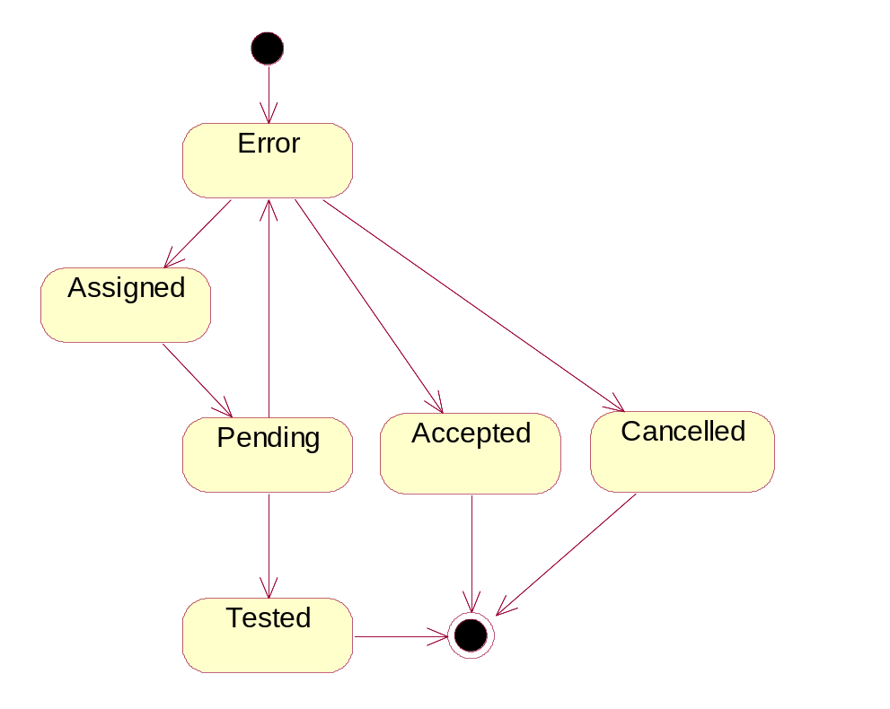
Figure 2.1.1: Defect life cycle

Description:
- A problem is logged into DMS -> status = Error
- PM/PTL verify the logged problem
  - It’s really a bug - assign to Developer fix -> change status = Assigned
  - It’s NOT a bug -> change status = Cancelled
  - It’s really a bug but no need fix at this project (by any reason) -> change status = Accepted
- Developer fix bug -> change status = Pending
- Tester verify bug again
  - Bug is really fixed -> change status = Tested
  - Bug is NOT fixed yet -> change status = Error again

Current status |  |  | Next status
Relationship | 1-Error | 2-Assigned |  | 3-Pending | 4-Tested | 5-Accepted | 6-Canceled | End
1-Error |  | x |  |  |  | x | x
2-Assigned |  |  |  | x
3-Pending | x |  |  |  | x
4-Tested |  |  |  |  |  |  |  | x
5-Accepted |  |  |  |  |  |  |  | x
6-Cancelled |  |  |  |  |  |  |  | x

Others requirement
  - Header of page
    - Overview
Always display Header in all screens.
    - External interfaces
      - Prototype:
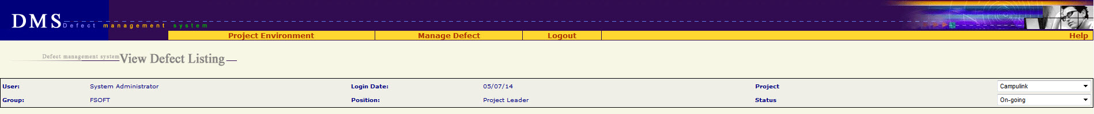
      - Screen description
No | Field name | Control type | Data type | Description
1 | Project Environment | Menu | Text
2 | Assign User | Menu | Text | Submenu of “Project Environment” menu
3 | Work Product | Menu | Text | Submenu of “Project Environment” menu
4 | Module | Menu | Text | Submenu of “Project Environment” menu
5 | Setup Environment | Menu | Text | Submenu of “Project Environment” menu
6 | Mange Defect | Menu | Text
7 | Manage Views | Menu | Text | Submenu of “Mange Defect” menu  Go to Home page
8 | New Defect | Menu | Text | Submenu of “Mange Defect” menu  Go to Add New defect screen
9 | Manage Planned Defect | Menu | Text | Submenu of “Mange Defect” menu
10 | Project Summary | Menu | Text | Submenu of “Mange Defect” menu
11 | Import Defect | Menu | Text | Submenu of “Mange Defect” menu
12 | Logout | Menu | Text | Logout system, go to Login screen
13 | Help | Menu | Text | Download & open file “Guideline_Defect Management System.doc”
14 | Defect management system <screen name> | Label | Text
15 | User | Label | Text | Value = type of login user
16 | Group | Label | Text | Value = group of login user
17 | Login Date | Label | Text | Value = today  Date format = mm/dd/yy
18 | Position | Label | Text | Role of login user
19 | Project | Combo box | Text | List of project which login user is assigned  Default value = the current project
20 | Status | Combo box | Text | Status of project  Default value = the current status of project

  - Data Format
    - Date/Time Format
Default date format is mm/dd/yy For example: 05/29/14
Default time format is hh:mm:ss For example: 07:23:55
    - Number Format
No zero at prefix
File size: xx.x KB For example: 192.3 KB
Available size: xx KB For example: 456 KB
Order number has no comma separated For example: 12345
Decimal places of % is 1 For example: 25.7%

  - Order of reference data
    - QC Activity
10-Unit test (Type of Activity = Test)
11-Integration test (Type of Activity = Test)
12-System test (Type of Activity = Test)
13-Acceptance test (Type of Activity = Test)
14-Regression test (Type of Activity = Test)
15-After release test (Type of Activity = Test)
16-Other test (Type of Activity = Test)
17-Prototype test (Type of Activity = Test)
20-Document review (Type of Activity = Review)
21-Code review (Type of Activity = Review)
22-After release review (Type of Activity = Review)
23-Prototype review (Type of Activity = Review)
24-Other review (Type of Activity = Review)
30-Quality gate inspection (Type of Activity = Inspection)
31-Final inspection (Type of Activity = Inspection)
32Other inspection (Type of Activity = Inspection)
33-UT inspection (Type of Activity = Inspection)
40-Baseline audit (Type of Activity = Audit)
41-Other audit (Type of Activity = Audit)
    - Defect Origin
Administration
Coding
Collaborator Management
Configuration Management
Contract Management
Correction
Customer Support
Deployment
Design
Document Control
Facility Management
IS Management
Internal Audit
Management Review
Other
Prevention
Process Improvement
Project Management
Quality Control
Quality Planning
Recruitment
Requirement
Retirement
Staff Management
Student Management
Subcontract Management
Technology management
Test
Training
    - Type of Activity
1. Review
2. Test
3. Inspection
4. Audit
    - Stage Injected / Stage Detected
<blank>
1-Initiation
2-Definition
3-Solution
4-Construction
5-Transition
6-Termination
Definition&Solution
Initiation&Definition
Release 1
Release 2
Release 3
Release 4
Release 5
Release 6
Solution&Construction
    - Priority
<blank>
1-Immediately
2-High
3-Normal
4-Low
    - Work product
Acceptance note
Architectural design
Audit program
Audit record
Audit report
Baseline Audit
Baseline report
CM Plan
Change request
Coding convention
Configuration Status Report
Contract
Customer Satisfaction Survey
DAR Report
DP Plan
DP report
Database
Deployment package
Design prototype
Detailed design
Final inspection
Handover note
IP
IP database
Installation manual
Integration test case
Integration test plan
Integration test report
Meeting minutes
Others
PCB
PQA report
Pilot plan
Pilot record
Pilot report
Plan
Process assets
Process database
Program
Project assests
Project database
Project plan
Project record
Project report
Proposal
Prototype
QA report
QA review record
QDS
Quality control report
Quality gate record
Record
Release note
Report
Requirement prototype
Resource and environment
Review TestCase
Review record
SQA report
SRS
Service Level Agreement
Software module
Software package
Support Diary
System description
System test case
System test plan
System test report
Test data
Test plan
Test script
Traceability matrix
Training course
Training material
Training records
URD
Unit test case
Unit test plan
Unit test report
Use case
User manual and WO
    - Severity
1-Fatal
2-Serious
3-Medium
4-Cosmetic
    - Module / Module Code
<Blank>
<List of module which got from another Project management tool>
    - Type
01-Functionality (Other)
011-Req misunderstanding
012-Feature missing
013-Coding logic
014-Business logic
02-User Interface
03-Performance
04-Design issue
05-Coding standard
06-Document
07-Data & Database integrity
08-Security & Access Control
09-Portability
10-Other
11-Tools
    - Defect owner, Assigned To,
All member of project are ordered by alphabet :
<Blank>
<Member 1>
…..
<Member n>
    - Status
1-Error
2-Assigned
3-Pending
4-Tested
5-Accepted
6-Canceled
  - Timeout requirement
All screens have timeout of 1 hour
After timeout, user has to re-login, and does his/her previous step by step once again.
  - Message list
Message Code | English Content
ERR_FORMAT_DATE_CREATED | Created Date is invalid
ERR_FORMAT_DATE_CREATED_FROM | "From Created Date" is invalid.
ERR_FORMAT_DATE_CREATED_TO | "To Created Date" is invalid.
ERR_FORMAT_DATE_FIXED | "Fixed Date" is invalid.
ERR_FORMAT_DATE_FIXED_FROM | "From Fixed Date" is invalid.
ERR_FORMAT_DATE_FIXED_TO | "To Fixed Date" is invalid.
ERR_FORMAT_DATE_DUE | "Deadline" is invalid.
ERR_REQUIRED_SEVERITY | "Severity" is required
ERR_REQUIRED_TYPE | "Type" is required
ERR_REQUIRED_TYPE_ACTIVITY | "Type of Activity" is required
ERR_REQUIRED_QC_ACTIVITY | "QC Activity" is required
ERR_REQUIRED_ORIGIN | "Defect Origin" is required
ERR_REQUIRED_WP | "Work Product" is required
ERR_REQUIRED_CREATED_DATE | "Created Date" is required
ERR_REQUIRED_TITLE | "Title" is required
ERR_REQUIRED_DESCRIPTION | "Description" is required
ERR_REQUIRED_STATUS | Ignore this message because status cannot be blank
ERR_REQUIRED_DEFECT_ORIGIN | Ignore this message because defect origin cannot be blank
ERR_DEFECT_ID_INVALID | Defect ID must be positive number
ERR_REQUIRED_ATTACHMENT_FILE | Please select at least one file to attach
ERR_FILE_OVER_AVAILABLE_SIZE | Attachment size exceeds available space
ERR_FILE_OVER_MAX_FILE_SIZE | Attach size exceeded
ERR_EXISTED_FILE_NAME | The attached file already exists!
ERR_CONSTRAINT_DATE_CREATED_FROMTO | "From Created Date" cannot be later than "To Created Date"
ERR_CONSTRAINT_DATE_FIXED_FROMTO | "From Fixed Date" cannot be later than "To Fixed Date"
ERR_CONSTRAINT_DATE_CREATED_TODAY | "Created Date" cannot be later than today
ERR_CONSTRAINT_DATE_CREATED_DUE | "Created Date" cannot be later than "Deadline"
ERR_CONSTRAINT_DATE_CREATED_FIXED | "Created Date" cannot be later than fixed date
ERR_CONSTRAINT_DATE_FIXED_TODAY | "Fixed Date" cannot be later than today
ALT_PAGE_INVALID | Your number is out of range
ALT_REQUIRED_DEFECT | Defect(s) is required
ALT_REQUIRED_EXPORT_LIST | Some items must be selected

